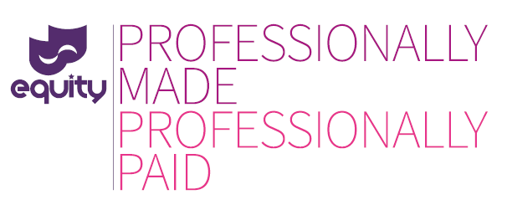

Thank you for getting in touch regarding your production. Unfortunately, I will not be taking up the chance to work with you on this occasion.
I am a proud member of Equity, the trade union for entertainment industry professionals. While Equity members understand all too well how difficult it can be to raise a budget for a production, especially if you are a new company, we feel strongly that industry professionals deserve to be paid for the work that they do. To this end, Equity works with companies big and small to support lawful contracts and sustainable production companies. Equity produce a great deal of information about lawful, affordable contracts and employment terms on our website at www.equity.org.uk/pmpp
I urge you to read the Equity website and contact Equity’s Low Pay and No Pay Organiser, Karrim Jalali on kjalali@equity.org.uk or 020 7670 0138 or Films Official Amy Dawson on adawson@equity.org.uk with any questions. They can help you offer an Equity contract for your production. This may be more affordable than you think and creates a clear, efficient framework for avoiding and resolving problems during the production and identifies you as an ethical employer.
Using an Equity agreement also protects you from the potential legal challenges which can arise from using substandard contracts that do not respect statutory minima. You should also be aware that by not offering at least national minimum wage you may be leaving yourself open to possible legal action under the terms of the National Minimum Wage Act 1998, and a potential fine of up to £20,000. www.gov.uk/national-minimum-wage/employers-and-the-minimum-wage
I hope this information has been of some use to you and that you will contact Equity to begin to develop a positive working relationship. Many companies like yours have contacted us, and are now enjoying the benefits.
Yours sincerely,

